SIMs user groups

- Improvements to memory leak in PULSAR.exe
- Highlighting inactive lookups in the user interface
- Enable the print button in pupil bulk update screen
- Bulk update of the completed flag in a staff training event
- Warning to the user when adding a student as a contact

SIMS Assessment - Statutory Analysis Report for KS1
Resources are now available that support the analysis of KS1 outcomes using the revised measures for 2015/16.
Schools will already have access to their overall results from this year's statutory tests at KS1, the new SIMS assessment templates and linked report will provide schools with the ability to compare results for key pupil groups within their school against the national measures.
Updates made
06/11/2017 (version 1.3) Report Definition has been updated to reflect the National data figures published on 26th October (https://www.gov.uk/government/statistics/phonics-screening-check-and-key-stage-1-assessments-england-2017).
25/05/2017 (version 1.2) Template has been updated to reflect recent DfE updates to the conversion table
20/01/2017 (version 1.1) Updates have been made to remove the tick from the year group in the report filter and to digitally sign the report in order for SIMS hosted schools to be able to run it. The most recent file can be accessed below. Please note that only the RepDef file needs to be re-imported, all other files have been included in the .zip for completeness.

What do I need to do next?
Download the Marksheet Templates and Report Definition from here (version 1.3)
- Import the templates (Routines / Data in / Assessment/ Import)
- Import the report definition (Reports / Import)
- Create Marksheets from the templates (Focus / Assessment / Templates)
  - CAS KS1 Attainment Overview 2017
How does the report work?
If you have been using SIMS for your statutory reporting at KS1 and KS2, data will automatically populate into the marksheet.
- Open the Marksheet CAS KS1 Attainment Overview 2017
- Click calculate and save
- Run the report definition (Reports / Run report/ Focus - Student ) CAS KS1 Key Groups Overview 2017
The output report will then display analysis results for KS1 attainment for all key groups. An example of the attainment report is shown below.

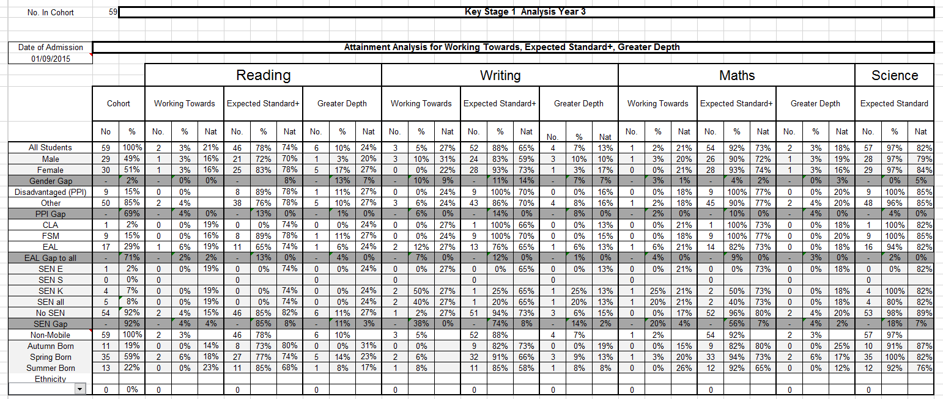

SIMS Assessment - Statutory Analysis Report for KS2
Resources are now available that support the analysis of KS2 outcomes using the revised measures for 2016/17
21/11/2017
Schools will already have access to their overall results from this year's statutory tests at KS1 and KS2, the new SIMS assessment templates and linked reports will provide schools with the ability to compare results for key pupil groups within their school against the national measures.
Progress measures from KS1 to KS2 have also been included which will rely on your school having complete up-to-date KS1 results for current cohorts (from Year 4 onwards including last year's Year 6). Results may differ from those provided by the DfE if historical KS1 results are missing. If you need help with this process please get in touch by calling 0800 170 1724.
Updates made
20/11/2017 (version 3.1) Adjustment have been made to the KS2 RefDef resource to ensure that attainment and progress calculate correctly for those pupils who got a Scaled Score in Reading and Writing and were Teacher Assessed as PKF, PKG or PKE
12/09/2017 (version 3.0) Template and RepDef have been updated to specifically address the progress made by pupils below the standard of the tests or assessments in 2017 as as detailed on pages 19-21 in the recently published DfE document. The template now picks up and converts P Scales and Teacher Assessments PKG, PKF and PKE into nominal scaled scores.
05/09/2017 (version 2.0) Template and RepDef has been updated to reflect the significant changes to the prior attainment calculations outlined in the recent DfE primary school accountability measures for 2017
25/05/2017 (version 1.5) Template has been updated to reflect recent DfE adjustments to the conversion table
20/01/2017 (version 1.4) Updates have been made to remove the tick from the year group in the report filter and to digitally sign the report in order for SIMS hosted schools to be able to run it. The most recent file can be accessed below. Please note that only the RepDef file needs to be re-imported, all other files have been included in the .zip for completeness.
11/01/2017 (version 1.3.1) It has been noted that the previous KS2 RepDef update included the Agency name as Water Edge, this has since been updated to CAS Report Services. The most recent file can be accessed below. Please note that only the RepDef file needs to be re-imported, all other files have been included in the .zip for completeness.
05/01/2017 (Version 1.3) Updated GPS national score from 72% to 73% as per DfE revised statistical release.
09/12/2016 (Version 1.2) 2 x changes made: 1) Rectified error in cell G24 showing as SEN,”S” instead of SEN “E”. 2) Changed Term of Birth formula to calculate pupils born in April to be summer born in line with the DfE and SIMS
24/11/2016 (Version 1.1) to include the latest national figures from RAISEonline and ensure APS scores are now calculating for Low, Mid and high attainers.

What do I need to do next?
Download the latest Marksheet Templates and Report Definition from here (version 3.1)
- Import the templates (Routines / Data in / Assessment/ Import)
- Import the report definition (Reports / Import)
- Create Marksheets from the templates (Focus / Assessment / Templates)
  - CAS KS1 APS Calculator 2016
  - CAS KS2 Attain and Progress Tests 2016
How does the report work?
If you have been using SIMS for your statutory reporting at KS1 and KS2, data will automatically populate into the marksheet.
- Open the Marksheet CAS KS1 APS Calculator 2016
- Click calculate and save
- Open the Marksheet CAS KS2 Attain and Progress Tests 2016
- Click calculate and save
- Run the report definition (Reports / Run report/ Focus - Student ) CAS KS2 Key Groups Overview 2016
The output report will then display analysis results for KS2 attainment and KS1 - KS2 progress for key groups. An example of the attainment report is shown below.
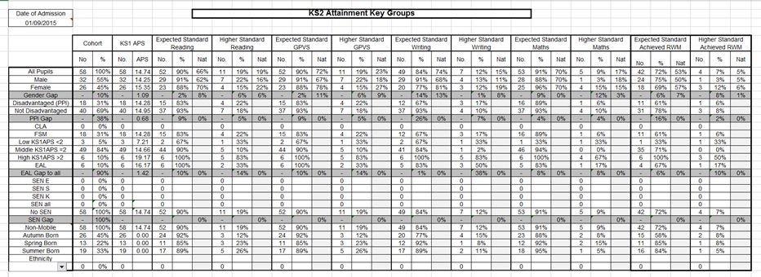

Following the summer release of SIMS 7.176, there are new versions of some of the KS4 resources. These can be found here along with the latest versions of all of the resources. Please read the following notes carefully.
1. CAS KS4 Overview templates 2017 to 2020
These new versions contain additional subjects not present in the previous versions of the mapping tool and templates, such as IFS Level 2 Financial Education, Cambridge and NCFE Certificates in Health and Social Care and Fitness, OCR L1/2 Engineering Qualifications, some Level 2 RSA music qualifications and also some Music grade 6 -8 exams which can count in the Open slot of the P8 calculation.
- In order to use the mapping tool to map to these new aspects you will need to update to the SIMS summer release.
- If you do not need to map these new aspects as they are not relevant to your school, there is no need to import these new templates as there is otherwise no change to the calculations.
- If you do import and use these aspects but have previously mapped an aspect to a similar but substitute aspect to one now included above, please ensure after mapping to the new aspect that results in the substitute aspect are deleted so as not to count them twice when the marksheet is recalculated for any particular result set.
- One aspect which was unfortunately not made in time for the summer release was the Combined Science aspect being examined from 2018 onwards. Please continue to use the Double Science (9-1) aspect which will behave as a very close approximation in the meantime.
- As always, these new versions should import over the previous TP Year 10 Autumn templates, but will then need to be cloned for other result sets.
- There will be new qualifications approved and added to the mapping tool and templates in the future, and further template updates will be provided to include these. If a particular qualification is not yet there, it is perfectly acceptable and just as accurate to use a similar qualification as a substitute in the meantime, as long as the substitute uses the same grade set and counts in the same ‘slots’ as the actual one required.
2. New versions of the scatter graphs (now 2.1)
These now contain additional options for highlighting one or more of the following key groups: gender, PP, FSM, SEN and EAL. A double click on a data point now shows all of the students referred to. To use these graphs simply...
- Open a completed, calculated CAS KS4 Overview marksheet.
- Right click above the student column and add the gender, Pupil Premium, FSM, SEN and EAL columns
- Export the marksheet into Excel in unformatted mode
- Open the Scatter Graph Excel file (Excel 2010 or 2013 depending on the version installed at the school), and click the Raw Data tab.
- Firstly copy the student names and Pupil Information columns from your exported file and paste them over the equivalent dummy data columns on the scatter graph file.
- Then copy the columns from the KS2 Average Fine Points Score column onwards, and again paste over the dummy data.
- The graphs should then populate with the school’s data.
- Double click on a data point to see the name(s) of students.
- Click the check boxes and click the button to highlight certain students in red. (note the highlighting does not remove data points from the chart, so clicking the point will still show all the students, not just those highlighted in red.
Please note that if there is a small number of students in a cohort, you may need to reduce the ‘order’ of the trend line for the data to display correctly

23539 (England, Wales and Northern Ireland) - Update to JC Gradesets for GCSE 9-1 Short Courses
We have received a number of calls from customers where importing basedata that includes new GCSE 9-1 short courses have failed. Applying patch 23539 will update Exams JC Gradesets JC 40/2 Result and JC 44/2 Result. If after applying the patch you still get import errors from Edexcel and OCR, please continue to log a case with the service desk.
23486 (England) - Updated Estimated Attainment 8 Figures
Earlier in October, the DfE released their updated Provisional Estimated Attainment 8 figures for 2017. We have made this patch available to customers so the PI Reports, Attainment and Progress 8 calculations are accurate.

Supporting Subject Access Requests in SIMS for GDPR and DPA
New feature in the SIMS Autumn 2017 to support schools with Subject Access Requests
27/09/2017

How is SIMS supporting Subject Access Requests?
A Subject Access Request (SAR) made by an individual can involve a lot of work for a school. Data from many various sources need to be gathered, ranging from the paper filing cabinet to the core MIS. Currently in SIMS a user will need to design and run many custom reports to support existing outputs to form part of their SAR. Managing this number of reports can be a challenge.
In the Autumn release of SIMS .net, we are introducing a new routine called the Person Data Output. This has been designed specifically to reduce the number of separate reports required to fulfil a SAR.

How can I find out more information?
We have made available the following PowerPoint presentation to outline the process and highlight some important information about subject access requests. If you have any specific questions regarding SARs, then please contact paul.featherstone@capita.co.uk.

Product Developments to help Schools with GDPR
GDPR comes into effect in May 2018, how will SIMS help meet these new regulations?
02/11/2017

What do we believe the main concerns are that schools have around GDPR?
When discussing GDPR with schools, the main themes for concern in relation to the SIMS Suite of software are:
- Right to access
- Consent
- Data retention
- Deletion of data
Taking each of these themes in turn, we will discuss how SIMS can help at the moment and what our plans are for future developments.

Right to Access
The right to access is one of eight rules under the title of ‘Individual Rights’ and builds upon existing Data Protection Act legislation in the form of a Subject Access Request (SAR). When a school receives a SAR, there will be many separate reports in many different formats that a user in SIMS will need to produce to fulfil the request. This can be time consuming and a burden, to help address this, in the Autumn 2017 release of SIMS we are introducing some new functionality called the Person Data Output (PDO). Lots of information about this can be found here:
- Video demonstrating the PDO functionality
- Presentation on PDO enhancements
- Webinar links on GDPR which will include PDO on the 9th November and 5th December.
Initially the PDO will be available for Students with the export being introduced for Staff in the Spring 2018 release with options for outputs in a machine readable format (Data Portability).

Consent
Historically in SIMS it has been possible to record whether or not a parent has given their consent, for example, to allow the school to publish photographs of their son or daughter on a school website or newsletter. We allow schools to configure different consent options in SIMS and allow for this to be updated in bulk. This is where consent in GDPR has changed;
“Consent under the GDPR must be a freely given, specific, informed and unambiguous indication of the individual’s wishes. There must be some form of clear affirmative action – or in other words, a positive opt-in – consent cannot be inferred from silence, pre-ticked boxes or inactivity. Consent must also be separate from other terms and conditions, and you will need to provide simple ways for people to withdraw consent. Public authorities and employers will need to take particular care to ensure that consent is freely given.” (quote from the ICO).
This can imply that a school will now need to seek consent for a school to use their data for emailing or texting. However, direction from the ICO is that consent should be the last legal option for processing data. Many schools will have other avenues they can use to process an individual’s data, this will be mainly from a legal basis for statutory returns for example, or in a privacy notice. At this time, Capita see no basis or reason to evolve or enhance the current consent feature in SIMS.

Data retention
Where a school has a data retention policy in place, we know that implementing this in SIMS is difficult. We know that while a user is able to delete data from a record, it is not possible to do this in bulk, something that customers have been requesting for a number of years. This particular process has been considered many times for SIMS, but other pressures on statutory requirements has led us not to develop this type of functionality.
While the requirements around data retention under GDPR is not significantly different from the Data Protection Act, we must address this and make a concerted effort to make improvements in 2018. This feature (as with deletion mentioned below) is very complicated and will require a significant amount of analysis and development as there are many things we need to consider. Our plan is to start work on this during the Summer construction phase of the software (this is initiated around the end of January 2018), but due to the complexities, it is likely that the functionality won’t be ready until the Autumn of 2018.

Deletion of Data
Where the data retention work is focused on deleting pockets of data, i.e. Achievements, from a selection of Students, i.e. those who left the school 10 years ago, for a date range, this deletion is the deletion (or where required, anonymisation) of an entire persons record, this is referred to under GDPR as ‘the right to be forgotten.’
Like data retention, this is not a simple task, we have to consider how SIMS copes with linked records, previously run statutory reports and such a like, care will be given to the analysis of this work and we would hope to deliver this functionality in the Autumn of 2018.

For more information on GDPR…
Here are some other useful links:
- https://ico.org.uk/
- https://teaching.blog.gov.uk/2017/10/24/general-data-protection-regulation-evolution-or-revolution-for-schools/

Pupils Leaving
When a pupil leaves a school it is a very good idea to make use of Routines | Pupils | Leavers and to fill in the Destination Institution. There are a number of reasons for this being good advice from a statutory returns point of view
- If a pupil returns to the school after being on roll at another school their DOA should the latest date of arrival at the school. However, if they return to the school without being on roll at another institution their DOA for the purposes of statutory returns should normally be the previous date of arrival at the school.
- Under certain circumstances LAs in England can insist that the future school is supplied to the LA for the purpose of avoiding children going missing from education.

- SIMS Parent App demo site
- SIMS Primary demo site
- SIMS Options demo site
- SIMS Finance

